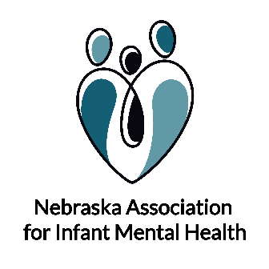
I/ECMH Partners Meeting hosted by NAIMH
Minutes
3.8.2022
Welcome & Introductions
History/Purpose of this meeting
- Discussed the history briefly of Early Childhood Mental Health (ECMH) in Nebraska- refer to attached timeline.
- The work has grown and with that comes more meetings, so last year we began to talk about joining with the Nebraska Association for Infant Mental Health and reducing burden by exploring a way to share information about work happening related to I/ECMH across systems.
Proposed Structure
- NAIMH’s mission is to promote the mental well-being and social emotional development of young children and their families. It is a neutral entity that brings organizations and individuals passionate about the work together.
- Will be an intentional and focused meeting on what is going around ECMH in Nebraska.
- We are proposing having quarterly meetings, that are just an hour.
  - Utilize a google form that will be formatted so information is shared consistently.
  - You can also use this form if you are not able to be at the meeting and have something to share that would be included in the minutes.
  - Sometimes you may have something to share, and sometimes you may not, you will only fill out this form to be on the agenda. This will help both with the minutes and to give time for everyone that has something to share.
  - We would like to try this and then will adjust as needed especially over the course of the next few meetings.
Hoping that this helps us be really intentional about the information we want to share related to ECMH and keeps the meeting focused as we know everybody is on meeting overload!

Small Groups
- Feedback about structure
- What do you hope to get out of this meeting?
- How does the information gathered at this meeting influence and align with your work?
- Anything else you would like the NAIMH board to consider that would elevate the usefulness of this meeting.
Next Steps
Will compile information from small groups and share, base future meetings on feedback obtained.

Upcoming Events & Training:
- Thinking Small Building Big: A Celebration of Infant Mental Health Endorsement in Nebraska and our Path to Endorsement.
  - April 6th 10 a.m.-12 p.m. CST.
- Pyramid TOT
  - April 11th and 12th – Lincoln (invite only)
  - July 25th and 26th – Kearney (invite only)
- EC Coach Training
  - January 24th-25th, 2022 (virtual)-by invite only
  - June 16th-17th, 2022 (virtual)-by invite only
  - September 8th-9th, 2022(virtual)-by invite only
- Pyramid Coach Training
  - Fall 2022 – TBD (virtual)-by invite only
- Parents Interacting with Infants (PIWI)
  - May 4th-5th, 2022, 9:00am-12:00pm CST
  - June 2nd, 2022 – Booster Training
- National Training Institute (NTI) on Effective Practices: Addressing Challenging Behavior
  - April 19th-22nd, 2022
- Nebraska Young Child Institute
  - June 28th and 29th, 2022– Younes in Kearney
  - Coach Booster June 30th, 2022– Younes in Kearney

